Unit 5: Gotta have it!

Speaking: discussing technology

Grammar: Infinitives and gerunds

Reading: A digital detox

Warm-up
- How do you use your phone?

Consider… time, purpose, place.
- Also: Apps, social media

Vocabulary
- Which vocabulary relate to you most? Why?
- Are there tech gadgets that you want but do not currently have?
- What is unnecessary?

Grammar
- Explanation: https://www.perfect-english-grammar.com/gerunds-and-infinitives.html

- Video: https://www.youtube.com/watch?v=v2_Qic03XFI

Reading
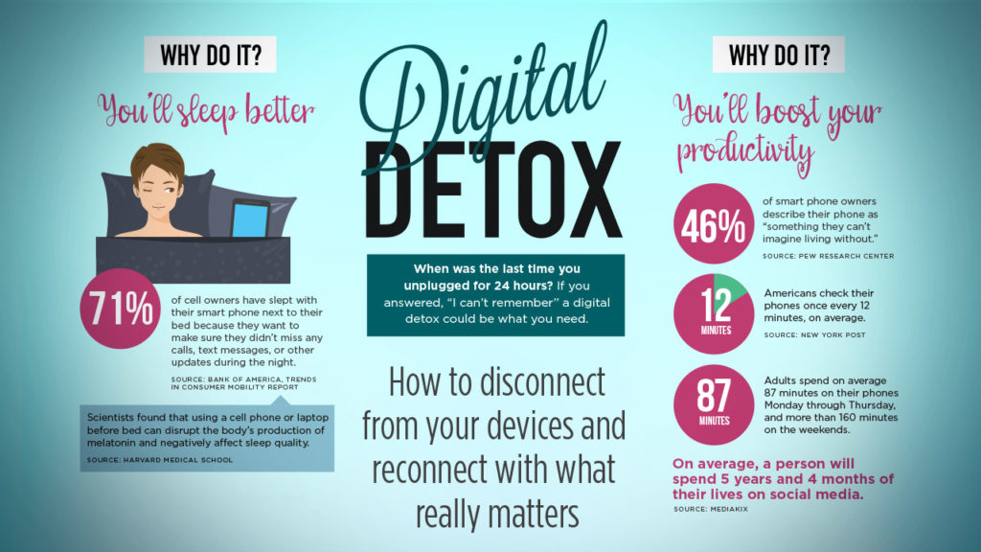

Conversation Questions

Conversation Questions:
- Do you get excited by new technology? What kinds of technology interest you?
- Is technology developing faster than it used to? Are you worried about being left behind?
- When you get a new product, do you read the instruction manual? Or do you just figure it out?
- How much time do you spend online each week? Is it too much time, or a reasonable amount?
- Advances in medical technology mean people are living longer. What are some of the downsides of this? How old do you hope to live?
- How do you feel if you forget your mobile phone and leave it somewhere?
- Which electronics brands do you trust most? Are you loyal to one brand?
- Do you play computer games? What do you say to people who believe they are a waste of time?
- Which social networking services (SNS) do you use? What do you like or dislike about them?
- How do you feel about dating websites or apps? Would you use one?

